



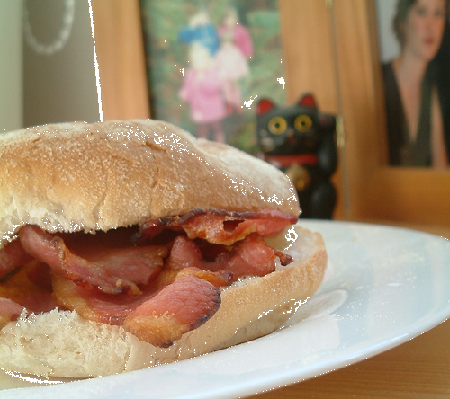


Tombola & Raffle
The Bothy Coffee Shop will be open
serving hot & cold drinks, pie & peas,
bacon/sausage sandwiches, chips.
Visit The Craven Collection
(just across the road) with over
250 Classic & Vintage Bikes
Entrance Fee £3.50

Entrance Fee £3.00
All proceeds from food, drink & entrance fee to the Craven Collection will be donated to the chosen charities
Ride from Dean’s Garden Centre, Seamer Road,
Scarborough at 6.30pm led by
KILHAM WEDNESDAY NIGHT BIKERS to
Dean’s at Stockton on the Forest for a fun night out!!!
ALL BIKERS WELCOME WHATEVER YOU RIDE!
TROPHIES FOR BEST CLASSIC & MODERN BIKES

COME BY BIKE IF YOU CAN
(ALTHOUGH CARS WILL NOT BE EXCLUDED!)
THANKS FOR YOUR SUPPORT
Tel No 01904 400141

Reg Charity No 284701
Reg Charity No 509294

